What is a JenkinsFile?
Jenkins pipelines can be defined using a text file called JenkinsFile. You can implement pipeline as code using JenkinsFile, and this can be defined by using a domain specific language (DSL). With JenkinsFile, you can write the steps needed for running a Jenkins pipeline.
The benefits of using JenkinsFile are:
- You can create pipelines automatically for all branches and execute pull requests with just one JenkinsFile.
- You can review your Jenkins code on the pipeline
- You can audit your Jenkins pipeline
- This is the singular source for your pipeline and can be modified by multiple users.
JenkinsFile can be defined by either Web UI or with a Jenkins File.
Declarative versus Scripted pipeline syntax:
There are two types of Jenkins pipeline syntax used for defining your JenkinsFile.
- Declarative
- Scripted
Declarative:
Declarative pipeline syntax offers an easy way to create pipelines. It contains a predefined hierarchy to create Jenkins pipelines. It gives you the ability to control all aspects of a pipeline execution in a simple, straight-forward manner.
Scripted:
Scripted Jenkins pipeline runs on the Jenkins master with the help of a lightweight executor. It uses very few resources to translate the pipeline into atomic commands. Both declarative and scripted syntax are different from each other and are defined totally differently.

Why Use Jenkin’s Pipeline?
Jenkins is an open continuous integration server which has the ability to support the automation of software development processes. You can create multiple automation jobs with the help of use cases, and run them as a Jenkins pipeline.
Here are the reasons why you use should use Jenkins pipeline:
- Jenkins pipeline is implemented as a code which allows multiple users to edit and execute the pipeline process.
- Pipelines are robust. So if your server undergoes an unforeseen restart, the pipeline will be automatically resumed.
- You can pause the pipeline process and make it wait to resume until there is an input from the user.
- Jenkins Pipelines support big projects. You can run multiple jobs, and even use pipelines in a loop.

Jenkins Pipeline Concepts
Term | Description
Pipeline | The pipeline is a set of instructions given in the form of code for continuous delivery and consists of instructions needed for the entire build process. With pipeline, you can build, test, and deliver the application.
Node | The machine on which Jenkins runs is called a node. A node block is mainly used in scripted pipeline syntax.
Stage | A stage block contains a series of steps in a pipeline. That is, the build, test, and deploy processes all come together in a stage. Generally, a stage block is used to visualize the Jenkins pipeline process.
Step | A step is nothing but a single task that executes a specific process at a defined time. A pipeline involves a series of steps.

Install Build Pipeline Plugin in Jenkins
With the build pipeline plugin, you can create a pipeline view of incoming and outgoing jobs, and create triggers which require manual intervention.
Here is how you can install the build pipeline plugin in your Jenkins:
Step 1) The settings for the plugin can be found under,
Manage Jenkins > Manage Plugins.
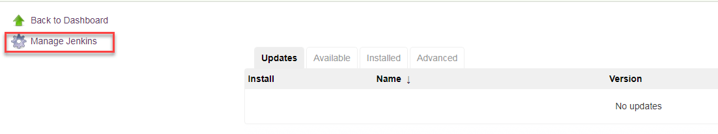
If you have already installed the plugin, it is shown under the installed tab.
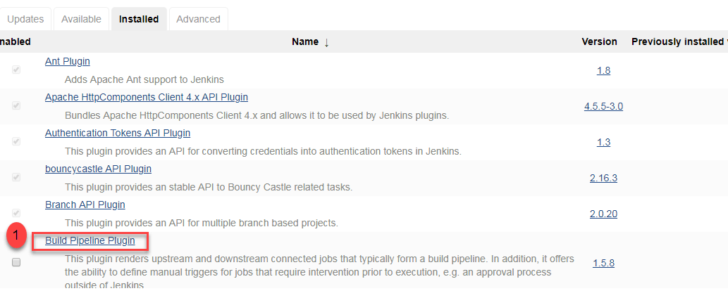
Step 2) If you do not have the plugin previously installed,
it shows up under the Available tab.
Once you have successfully installed the build pipeline plugin in your Jenkins, follow these steps to create your Jenkins pipeline:

How to Create Jenkins Pipeline
Once you are logged in to your Jenkins dashboard:
Step 1) Click on the “+” button on the left-hand side of your Jenkins dashboard to create a pipeline.
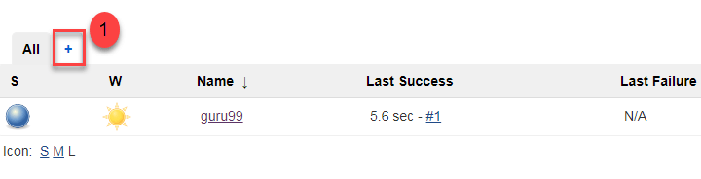
Step 2)
- You will be asked to give a name to the pipeline view. We shall call it “Guru99 Pipeline” for the duration of this demo.
- Select Build a pipeline view under options
- Click ok
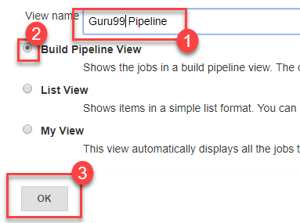
Step 3) In the next page, you will be asked for some more details to configure your Jenkins pipeline. Just accept the default settings, and make sure you choose the first job under the settings.
Click on Apply and then OK.
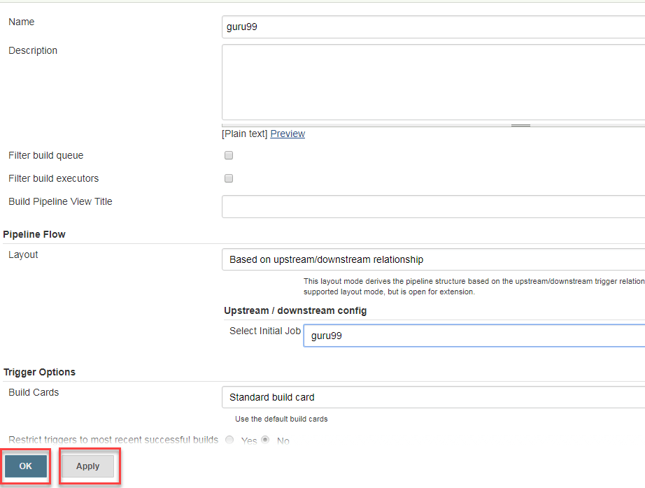
This will show you the sample pipeline view of your item, as given below:
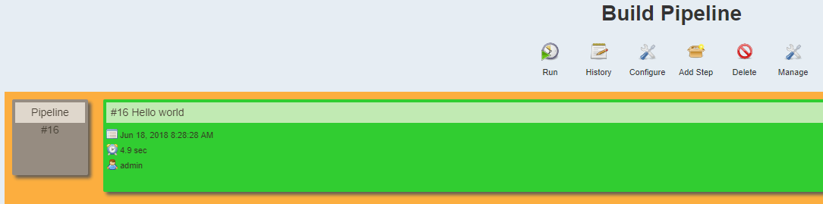

Running a Pipeline build
Step 1) For running a pipeline build, you need to chain your jobs first. For this, go to your first job and click on configure.
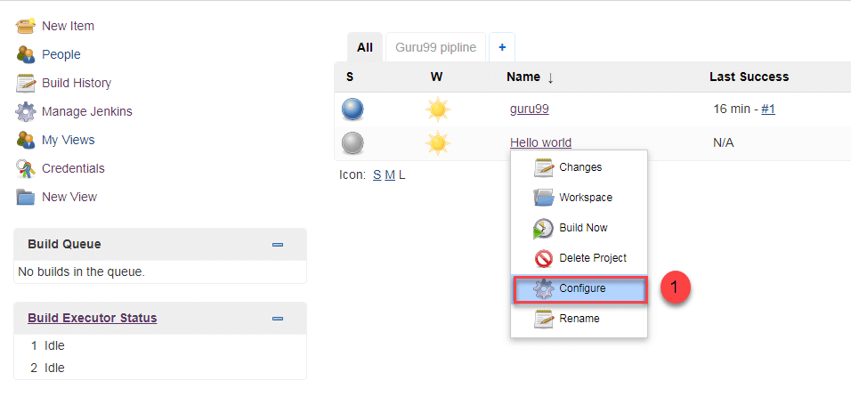
Step 2) Now, under Build Triggers, check the Build after other projects are built option.
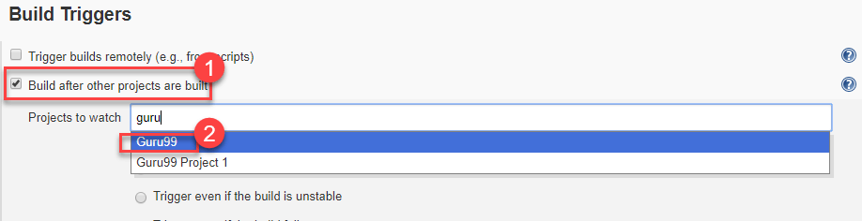
Thus, a chain for all your jobs has been created.
Step 3) Install the Build Pipeline view plugin if you don’t have it installed already.
Step 4) Go to your Jenkins dashboard and create a view by clicking on the “+” button. Select the Build Pipeline View option and click OK.
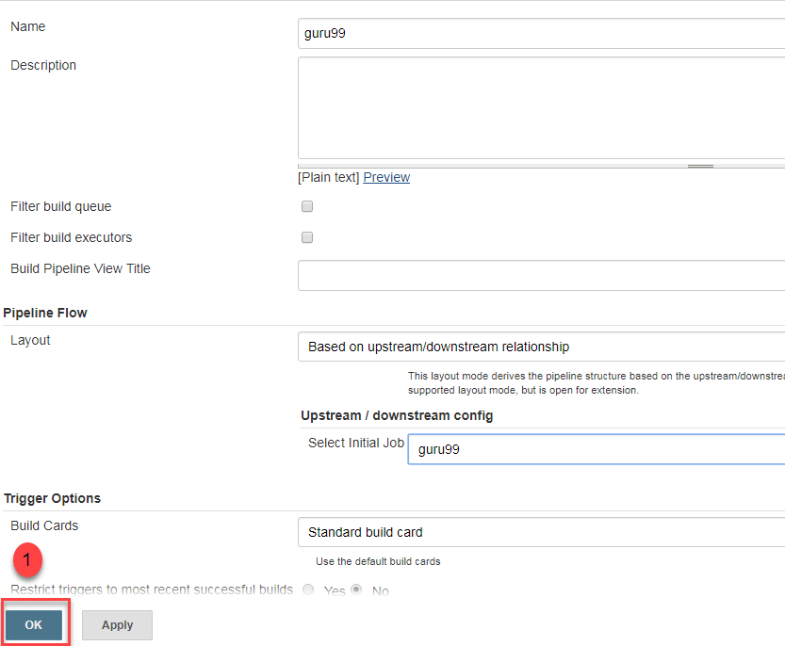
Step 5) Under Pipeline view configuration, locate Pipeline Flow.
Under Pipeline flow, select the initial job to run. Now choose the job which has chains to other jobs, as shown in Step 1 and Step 2.
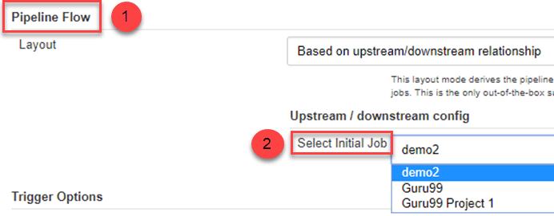
Here we have selected Guru99 Project 1 as the initial job, chained to other jobs. So, one by one, the jobs will run in the pipeline.
When the Jenkins pipeline is running, you can check its status with the help of Red and Green status symbols. Red means the pipeline has failed, while green indicates success.
In this Jenkins pipeline example, we see that the button is green. Hence, the pipeline is successful.
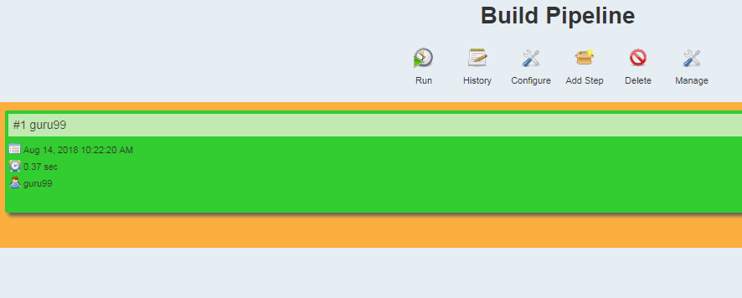

Running Jenkins pipeline
Click on Run to run the Jenkins pipeline. It will look something like this:
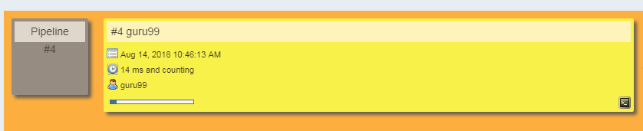
In the Jenkins pipeline script example above, we are demonstrating a simple “helloworld.java” program. But in real time projects, you will be responsible for creating and building complex pipelines in Jenkins. See below for a sample pipeline view.
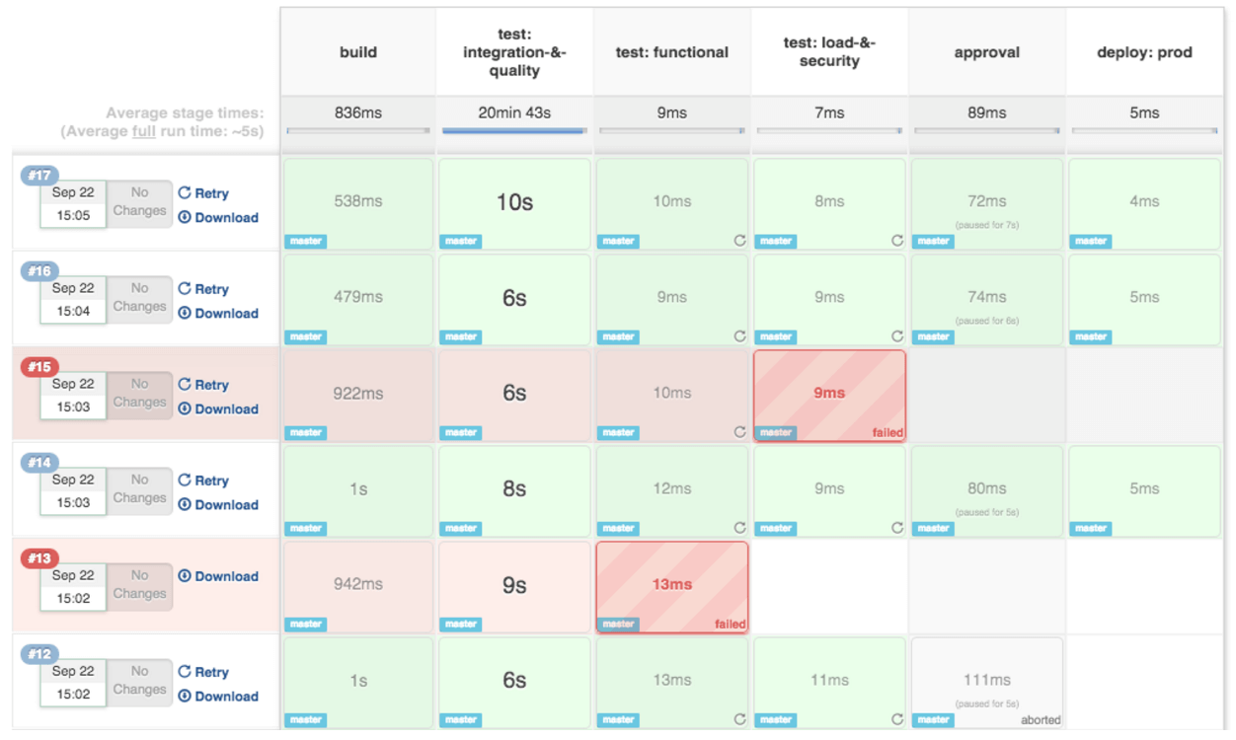
Best Practices using Jenkins Pipeline:
- Use the genuine Jenkins Pipeline
- Develop your pipeline as code
- Any non-setup work in your pipeline should occur within a stage block.
- Any material work in a pipeline must be performed within a node block.
- Don’t use input within a node block.
- Never set environment variables with env global variable
- Wrap your inputs in a timeout

